**Saturday May 5th, 1pm   
2 Blocks East from the F&M Bank, White Lake, SD  
Auctioneer’s Note:** The Frederickson family built the house in 1962 and have lived in it since that time. This auction presents an opportunity for seniors, young couple, single person or a rental property!

**ESTATE AUCTION**

**Real Estate& Personal Property**

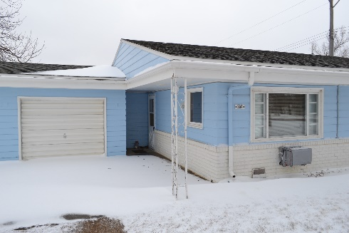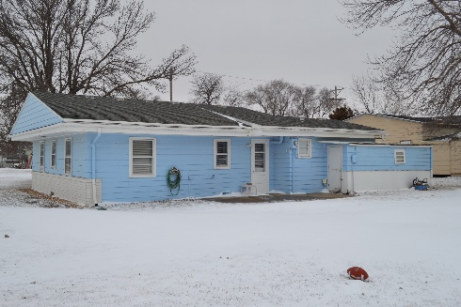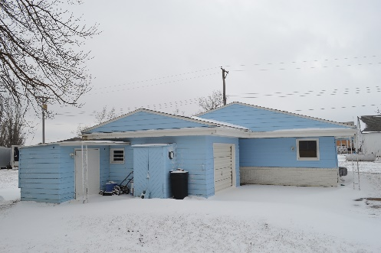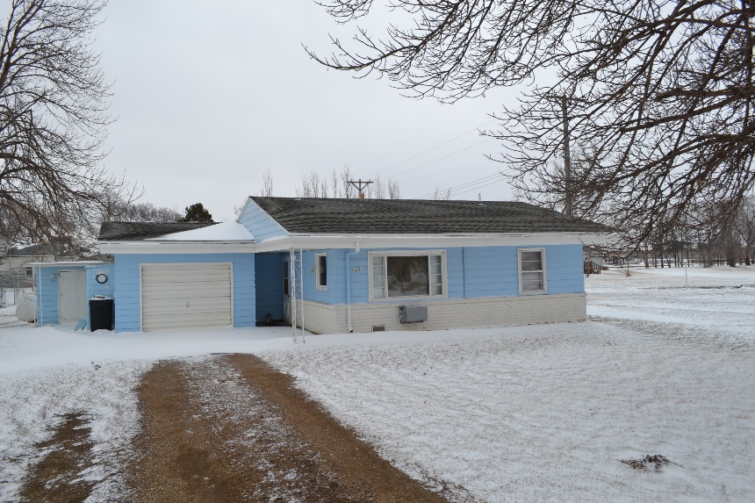

**Household Items**

3 flat screen TVs, kitchen table with 2 chairs, hide-a-bed sofa, glider rocker, double bed with dresser and night stand, white vinyl folding table, book shelves, glass front stereo stand, utility cart, bedding, dishes, pots, pans, utensils, small safe, books, rugs

**Fishing Equipment**

12’ aluminum boat with trailer, 2 electric trolling motors, depth finders, rods, reels, miscellaneous tackle and lanterns

**Other items too numerous to mention…**

**Legal Description**: South ½ of lots 5 & 6 BLK 27 DC GILLIS 2nd Addition 204 S Johnston St

**Don Frederickson Estate – Owner**

**Joan Thiry (605) 249-2355**

Sale Conducted by: **Haines Auction Company**

Complete listing can be found at **www.hainesauctions.com** or by contacting

Wayne W. Haines - Phone: 605-680-0612 - Email: hai9@midstatesd.net

**Appliances**

2 upright vacuum cleaners, carpet shampooer, 2 microwave ovens, console stereo (radio, turntable, cassette player), radios, fans, DVD player, VHS player, Small window air conditioner, sump pump, toaster oven, NuWave oven, 5 electric portable heaters, propane heater, lanterns

**Equipment & Tools**

250 gal propane tank, many hand tools, shovels, rakes, skill saws, jig saws, weed eater, garden hoses, wheel barrow, cords, battery chargers, saw horses, step ladders, multi-system ladders, flashlights

**Terms of Sale**: 15% non-refundable down the day of the auction with balance due upon delivery of warranty deed in approximately 30 days. Title insurance will be split 50/50 between buyer and seller. Buyer takes possession at closing. Announcements made d­­ay of the sale take precedence over printed material. Aurora County Title to handle closing. Haines Auction Company license # 12589 is representing the seller.

**Real Estate**

This home consists of 2 bedrooms, 1 bathroom and a single car attached garage all on a 1-acre lot located in a very desirable neighborhood walking distance to the White Lake Medical Clinic and new White Lake School! House is completely furnished with newer washer and dryer, counter top range, overhead oven, refrigerator, air conditioner and electric heat panels.