**Ranch & Equipment Auction TED E. SCHMIDT ESTATE**

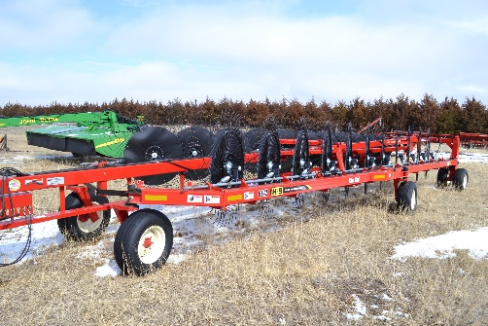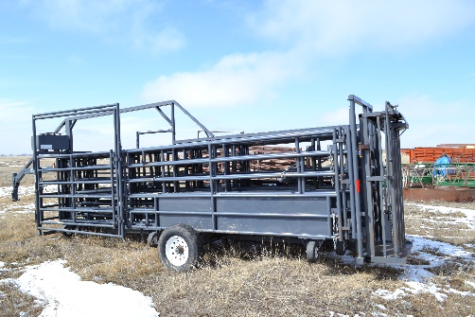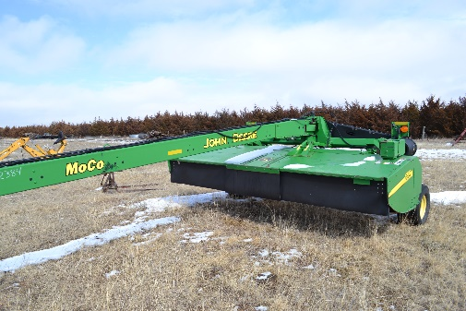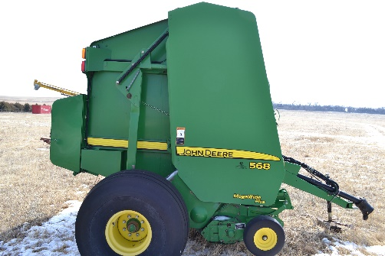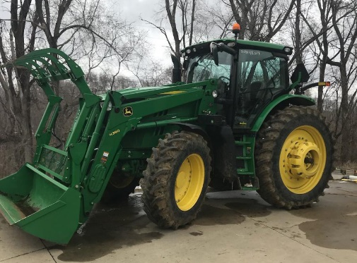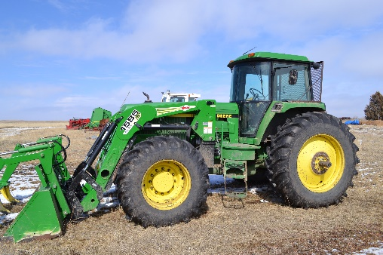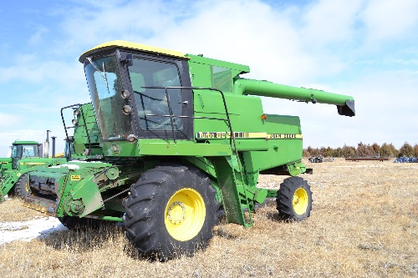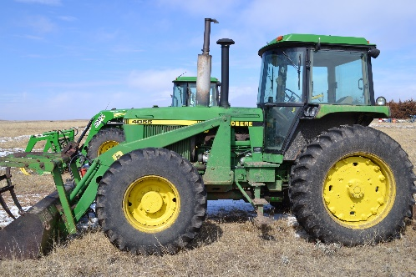

**Vehicles & Trailers**

1993 Ford F350 XLT crew cab – one owner, 1985 GMC Jimmy Sierra Classic, Honda Rubicon 4-wheeler, Honda Rubicon 4-wheeler (salvage), Polaris 4x4 sportsman 90 cc 4-wheeler, Ball hitch trailer single axles w/ramps, 20’ S/K gooseneck livestock trailer, 16’ bumper hitch stock trailer, Hillsboro 16’ 5th wheel combination dump box triple axle with hydraulic hoist, Aluminum flat bottom boat w/ trailer

**Livestock Equipment**

New Linn wrangler Electric over hydraulic portable corral gooseneck hitch head gate & chute, Parasal MFG portable cattle tub with gates & head stall, 20 - 16’ corral panels 8 bar high with portable chute, 15 - miscellaneous portable corral panels, 7 - big round bale feeders, 4 - Macksteel 20’ metal feed bunks, Electric calf warmer box- new, 2-wheel calf sled, poly calf sled, hip lift tool, OB chains, calf puller, 4 galvanized water tanks (4’ – 12’), branding stove, LP gas bottles, lick tubs, calf table

**Shop Equipment**

Electric Welder, cutting torch, air compressor, saws, drills, hammer, sockets, wrenches, jacks, log chains, oil barrels portable fuel tanks w/ 12 volt pump portable tank without pump, 300 gal fuel tank, metal pickup tool boxes, dozens of tires- many mounted on rims, belts, hoses, trouble lights, bolts, nails, screws

**Miscellaneous**

Dozens of deer heads, antlers sheds (white tail & muley), 40 plus double spring coyote traps, several tree stands, complete engines, transmission, pump jacks, live traps, tons & tons of old iron, salvage equipment, 8x20 metal shipping containers, Honda motorcycle

**Other items too numerous to mention…**

**Tractors**

**JD 6170R**: 2014 with 1140 hours, 4 remotes, MFWD, IVT, Independent-Link Suspension, JD H380 Loader with scoop & grapple.

**JD 4760:** Powershift FWA with Koyker 1585 pro loader with scoop & grapple 5300 hours new tires all around.

**JD 4055**: Powershift FWA with JD loader scoop & grapple 1989 model

**Bobcat S630:** 2010 Skid Steer, diesel, cab with heat, A/C, 2400 hours

**Case 2290**: Axle mount Duals 9100 hours 38” radial tires - Excellent

**Hay Equipment**

**Baler** - John Deere 568 mega wide pickup netwrap, big tires – 7 rolls of netwrap, **Rake** - H&S 6122 “V” Rake 22 wheels used 1 season, **Moco** - John Deere 956 Disc cutter 14’ nice condition, **Mowers** - Kosch Double nine mower, John Deere double 7 mower, Single axle chain hay mover, Several rear mount bale forks, Older chain style hay mover for parts

**Fencing Supplies**

100+ rail round ties, Dozens stockade Panels, used cable, 50+ highline poles various sizes & lengths, 6’ high chain-link fence, several hundred “T” steel posts, Electric fence posts & wire, Wire Stretchers, Electric fence charger, staples & clips, used lumber conveyor belting, used tin

**Machinery**

McConnel Ditch Boss 3-point backhoe 24” bucket with out-riggers, 2 - 10’ IH hoe Drills – 10” spacing with double drill hitch, 1 - 10’ IH hoe drill 10” spacing single hitch, 20’ IH tandem disc with harrow, 12’ JD chisel double spring with harrow, 12’ case tandem disc with harrow, JD 5’ rotary mower- rear mount

**Alfalfa Seed Equipment**

John Deere Combine 8820 turbo diesel hydrostatic w/ alfalfa sieves, John Deere 24’ 224 strait cut head w/ factory head cart, Windrow pickup header, Mayrath 6” PTO drive auger, 16 - 4” screw in grain aerator with electric fans, 40’ - 6” top drive PTO auger

**Saturday May 12th, 10:30 AM CST**

**Location:** From White River, SD 2 miles South 6.5 miles East - From Wood, SD 7 miles west and 3 miles South on White Wind Road

**Auctioneer’s Note:** Ted Schmidt was a well-known lifelong resident of Mellette County. He left us far too soon while doing what he loved most, caring for his livestock. This sale offering consists of everything you might need to run a cow calf operation and much more.

**Ted E. Schmidt Estate – Owner**

**Administrator: Danny Schmidt (712) 635-0949**

Sale Conducted by: **Haines Auction Company**

Photos & Complete listing can be found at **www.hainesauctions.com** or by contacting

Wayne W. Haines - Phone: 605-680-0612 - Email: hai9@midstatesd.net