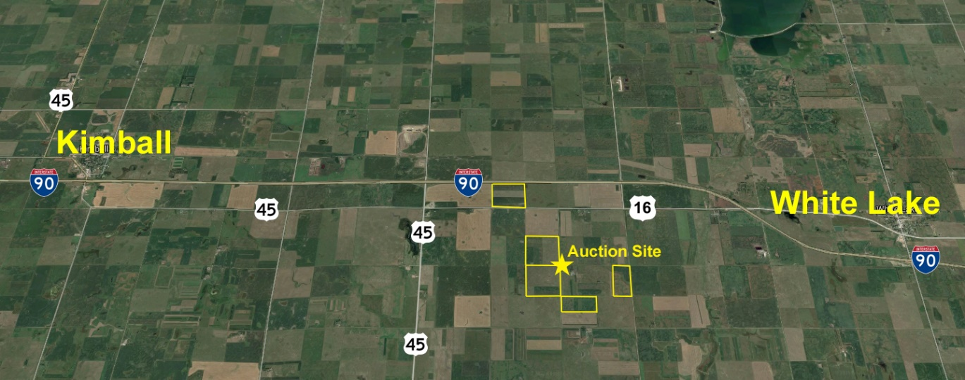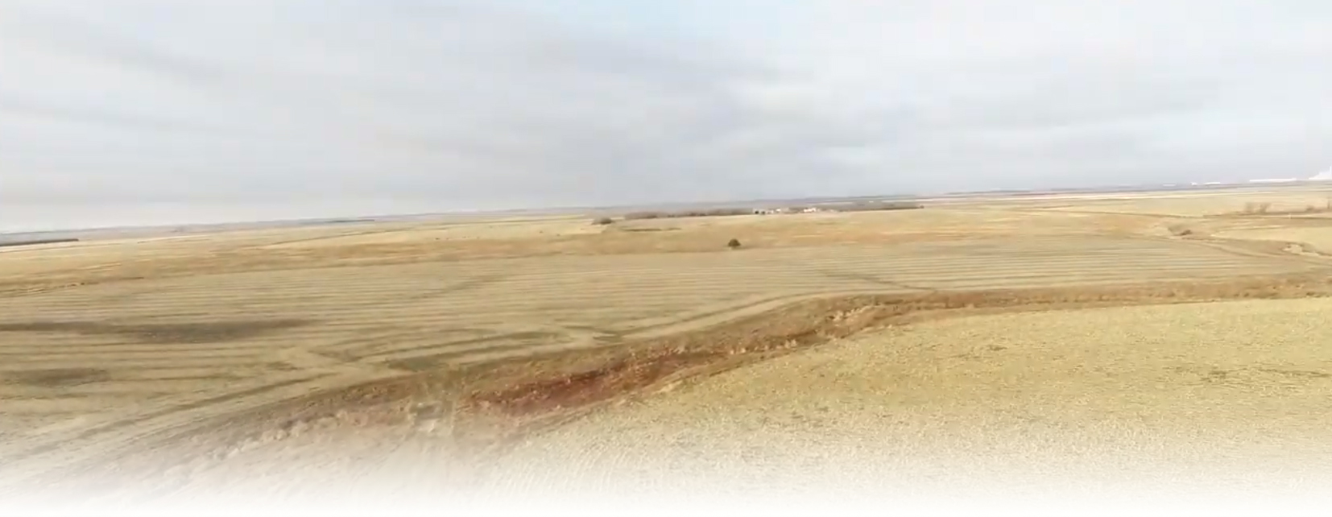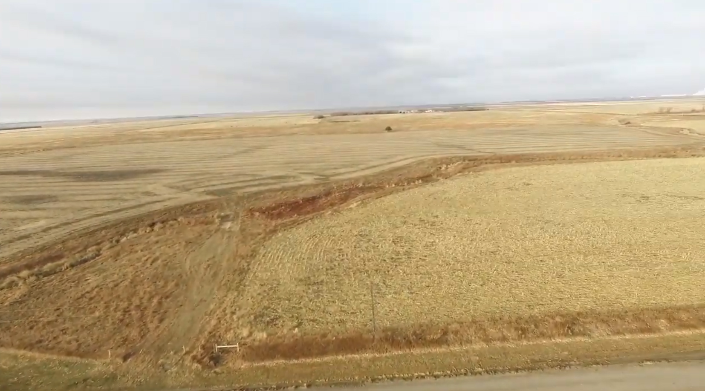

Brule County Land Auction

±621 Acres AcAcresacres

December 7th 1:00 pm CST

White River High School Gymnasium

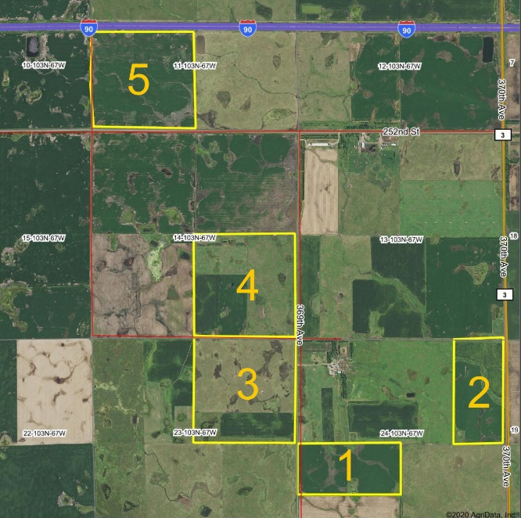

**Tract 1:** 80± Acres - This parcel is mostly all nearly level cropland with approximately 74 acres farmable with a crop productivity index of 73. Easy access with a gravel road access to the west side. Legal Desc: North 1/2 of South West quarter of SEC24 103N 67W - 2019 real estate taxes $969.92

**Tract 2:** 78± Acres - This parcel is mostly all nearly level cropland with 64 acres farmable with a crop productivity index of 75.8. A creek runs through this parcel and a small hay land in the southwestern corner. Gravel road access on the east side Aurora/Brule county line. Legal Desc: East 1/2 of North East quarter of SEC24 103N 67W - 2019 real estate taxes $979.20

**Tract 3:** 160± Acres - This parcel is a mixture of cropland and pasture. There are 35 acres farmable with a crop productivity index of 65. There are approximately 120 acres in pasture including 32 acres of tame grass. Aurora Brule Rural water tap in the northeastern corner. Gravel road access on the east side. Legal Desc: North East quarter of SEC23 103N 67W - 2019 real estate taxes $1,560.80

**Tract 4:** 158± Acres - This parcel is a mixture of cropland and pasture. There are 80 acres farmable with a crop productivity index of 67.6 There are 73 acres in pasture with 28 acres in tame grass and a dugout. Gravel road access on the east side. Legal Desc: South East quarter of SEC14 103N 67W - 2019 real estate taxes $1,572.82

**Tract 5:** 145± Acres - This parcel is mostly all nearly level cropland with 145 acres farmable and a crop productivity index of 67. Pave road access on south side and borders Interstate 90 on the north. Legal Desc: South West quarter of SEC11 103N 67W - 2019 real estate taxes $1,396.22

**Terms & Conditions:** The acreage amounts have been determined based on information obtained from the Brule County Assessor’s Office and other sources deemed reliable. This acreage will be used in calculating the final sale amount. The fences may or may not, be located on exact property boundary. Any fencing or surveying shall be the responsibility of the buyer. Property will be sold subject to seller confirmation.

Successful bidder shall make a 10% non-refundable earnest money deposit at the conclusion of the auction with the balance due in certified funds at closing on or before Monday March 1, 2021. Possession of the property shall be granted at the time of closing.

**Title:**  Title will be transferred by warranty deed. An owner’s policy title commitment showing merchantable title, subject to easement of record, will be provided and will be available for review at the time of the auction. There are currently no leases in effect on the property. The 2020 and all prior year’s taxes payable in 2021, shall be the responsibility of the seller. Davison-Aurora County Title Co. will manage the escrow and conduct the closing on all transitions

The closing agents’ fee, and cost of owner’s policy of the title insurance, will be divided equally between buyer and seller. All seller mineral interest (if any) transfer with the title. Announcements made day of sale take precedence over printed material. Haines Auction Company (license #12589) and their associates represents the sellers only in this transaction.

**Albert Thiry Trust – Marlene Haines & Steve Thiry Trustees**

Sale Conducted by: **Haines Auction Company** Email: hai9@midstatesd.net

More info can be found at **www.hainesauctions.com** or by contacting

Wayne W. Haines - 605-680-0612 - RE Broker/Auctioneer SD Lic. #12589

Duane DeBoer – 605-680-2412 - RE Broker/Auctioneer SD Lic. #3709

Terry Haiar – 605-239-4626 - RE Auctioneer SD Lic. #106

**Auction will be held at the land site - 25308 369th Ave White Lake, SD 57383  
White Lake** - 5 miles west on Old Hwy 16 then 1¼ mile south.  
**Kimball** - 7 miles east on Old Hwy 16 then 1¼ mile south.  
**I-90 Exit 289** – ½ mile south 2 miles east 1¼ mile south.

January 15th 1:00 pm

White River High School Gymnasium

**Auctioneer’s Note:** When evaluating this land to determine your level of participation make certain to fully appreciate the incredible location of these tracts; highway 16, Intestate 90, US highway 45, and Dakota Southern rail terminal all within minutes. This property has been in the Thiry family for generations, at no point has there ever been a renter or tenant on any of the land. 2019 real estate taxes $6,478.96

You will not want to miss this excellent opportunity. It offers productive crop land and excellent pasture ground right on the border of Brule and Aurora county. The property will be offered up in 5 separate tracts.