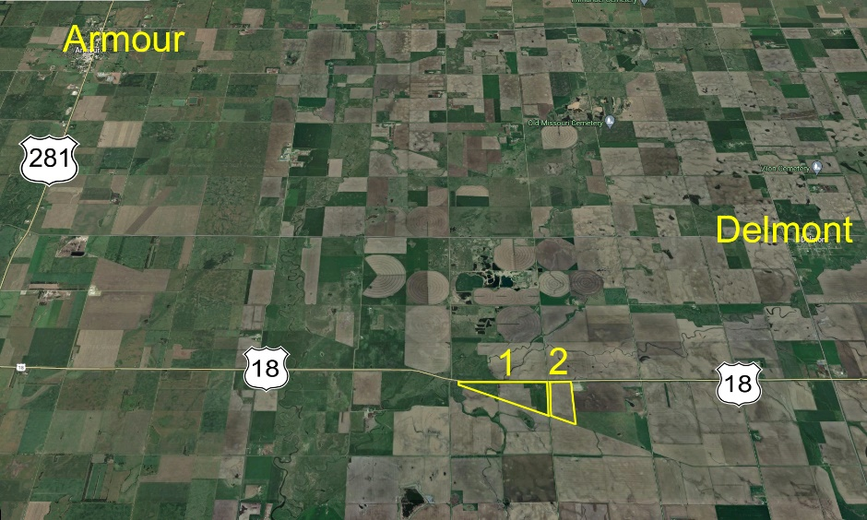****

**Auction will be held at the site – 39788 US Hwy 18 Delmont, SD 57330  
Armour** - 5 miles south on Hwy 281 then 6 miles east on Hwy 18.  
**Delmont** - 2 miles south on 401st Ave then 3 miles west on Hwy 18.

Estate Auction Douglas County, SD  
Farm Land & Personal Property

September 6th 11:00 am

White River High School Gymnasium

±200 Acres AcAcresacres

December 7th 1:00 pm CST

White River High School Gymnasium

**Auctioneer’s Note:** When evaluating this land to determine your level of participation make certain to fully appreciate the incredible location of these tracts; Over a mile of Highway 18 access. This property has been in the Geuther family for generations. 2024 real estate taxes $4,751.30

You will not want to miss this excellent opportunity. It offers productive crop land and excellent pasture ground right on the border of Douglas and Charles Mix County. The property will be offered up in 3 separate tracts.

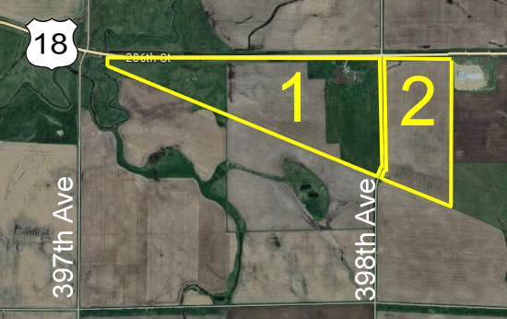

**Tract 1:** 125± Acres - This parcel is a mix of pasture, cropland, and homestead. 107 acres of farm ground and remainder in grass. A crop productivity index score of 70.9. Easy access with almost 1 mile of Hwy 18 access on the north. Legal Desc: Lots 1-2-3-4 of SEC12 97N 63W - 2024 real estate taxes $2,947.24

**Tract 3: Combination of tracks 1 & 2** consisting of ±200 acres a combined production index of 75.9 with more than 1 mile of Hwy 18 frontage, to be sold at greatest return to the seller.

**Tract 2:** 74± Acres - This parcel is mostly all nearly level cropland with 67 acres of cropland. A crop productivity index of 84.6. Gravel road access on the west side and Hwy 18 access on north side. Legal Desc: Lots 1-2 (Ex Lot H-1) SEC7 97N 62W - 2024 real estate taxes $1,804.06

**Terms & Conditions:** The acreage amounts have been determined based on information obtained from the Douglas County Assessor’s Office and other sources deemed reliable. This acreage will be used in calculating the final sale amount. The fences may or may not, be located on exact property boundary. Any fencing or surveying shall be the responsibility of the buyer. Property will be sold subject to confirmation of the court with a hearing presently scheduled for Thursday, September 12th, at 11 A.M. in the Douglas County Courthouse.

Successful bidder will be required to make a 10% non-refundable earnest money deposit at the conclusion of the auction with the balance due in certified funds at closing on or before Monday November 1, 2024. Possession of the property shall be granted at the time of closing.

**Title:**  Title will be transferred by a Personal Representative’s deed. An owner’s policy title commitment showing merchantable title, subject to easement of record, will be provided and will be available for review at the time of the auction. There are currently no easements in effect on the property. The 2024 and all prior year’s taxes payable in 2025, shall be the responsibility of the seller. Davison County Title Co. will manage the escrow and conduct the closing on all transaction.

The closing agents’ fee, and cost of owner’s policy of the title insurance, will be divided equally between buyer and seller. All seller mineral interest (if any) transfer with the title. Announcements made day of sale take precedence over printed material. Haines Auction Company (license #12589) and their associates represents the sellers only in this transaction.

**Jerry John Geuther Estate**

**Mae Gunnare (605) 661-7366 - Personal Representative**

**Skyler Mickelson, Morgan Theeler LLP - Attorney for Estate**

Sale Conducted by: **Haines Auction Company** Email: hai9@midstatesd.net

More info can be found at **www.hainesauctions.com** or by contacting

Wayne W. Haines - 605-680-0612 - RE Broker/Auctioneer SD Lic. #12589

**Farm Equipment**

Allis Chalmers 200 cab new tires  
Allis Chalmers D19 cab and new tires   
Allis Chalmers RC (1938 model)  
Allis Chalmers WD  
(3) Allis Chalmers WD 45’s   
Allis Chalmers baler & sickle mower  
Skid Steer  
John Deere baler  
John Deere manure spreader   
Farmhand 6-wheel rake  
2 upright fuel tanks

**Antiques & Misc**

J.C Higgins Model 20-12 GA, Daisey BB gun, Working Edison hand crank phonograph w/ platters, McCormic Deering cream separator, Numerous wooden antique dressers & chairs, Picture frames, Radio, Tonka Truck still in box, Local Advertising memorabilia, 2 writing desks, End tables, Various glassware, Singer sewing machine,1000-Gal poly tank, Air compressor

**Lunch will be available on site by Twin Rivers Old Iron Association**

**Vehicles**

2023 Husqvarna YTH1942 riding mower  
1991 Mercury Grand Marquis  
1962 Ford F100 Unibody Pickup  
Ford Fairlane   
1999 Honda 320 4 wheeler (needs repair)  
1959 Ford Galaxy 2 door Hardtop   
1976 Ford 500LTD 4 Door Hardtop

**Various other tools, household, & collector items too numerous to mention…**

**Note:** This auction will present an Allis Chalmers collectors dream.