
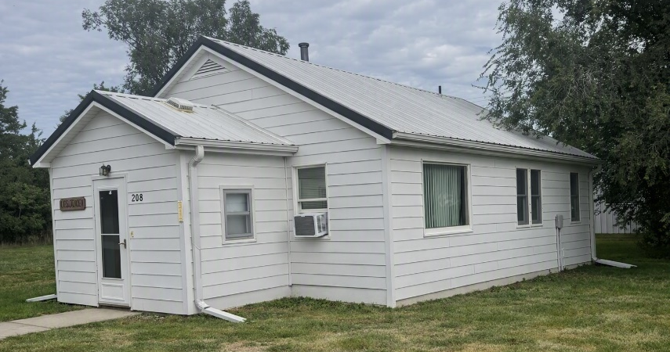
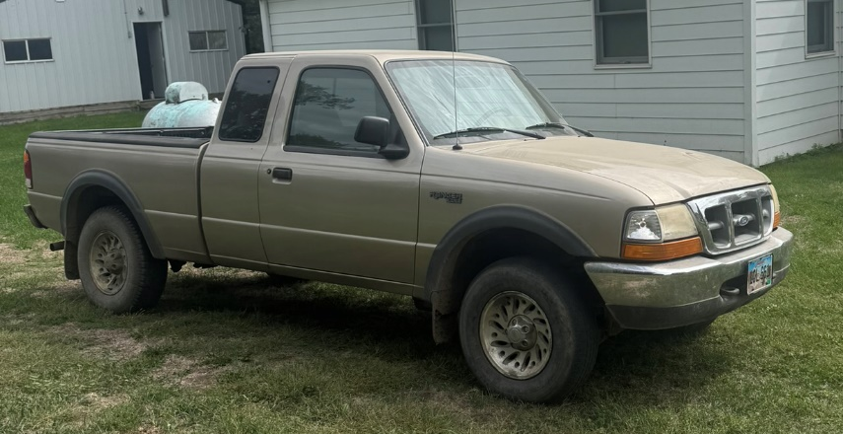
Real Estate
Modern, single story, two-bedroom, one bath, sitting on two lots. It is centrally located west of Main St. in White Lake, SD. The property has permanent siding, metal roof, and recent window replacement. The Property has a 24x30 two door pole frame garage with electric door openers and full electricity.

Term of Real Estate: 15% nonrefundable earnest money to be paid day of the sale. Balance due at closing, on or before November 1st 2026. 605 Title Company is handling the closing and deposits in this transaction.

Personal Property
1999 Ford Ranger 4x4 extended cab with 133K miles, Toro self-propelled 22” lawn mower with bagger-like new, new electric air compressor with hoses, 18 volt electric string trimmer with 3 batteries, Wayne sump pump, high lift jack, 2 like new aluminum scoop shovels, spade, sand shovels, garden hoses, electric cords, jumper cables, pitch forks, aluminum extension ladder, step ladder, spray cans, tree trim saw, gas cans, 3/8” socket set, 1/4 “ socket set, box and open end wrench sets, screw drivers, hammers, and hatchet

Sunday October 11th, 1:00 pm
One Block West of Main St. White Lake, SD - 208 South Hanten St.
Auctioneer’s Note: Les Jensen has been a lifelong resident of the White Lake community and has moved to the White Lake Care Facility. He has decided to sell his home and property at public auction. Come take a look!
Household & Antiques
Hardwood china cabinet w/mirror and drop-down secretary door, wood upright wardrobe w/glass in doors, old trunks and suitcases, Wooden nightstand, old six string guitar, pots and pans, crock pitchers and bowl, glass dishes, cooking utensils and flatware, oak rocking chair, press back wood chairs, bedroom set, recliner and sofa, flat screen tv with remote.

REAL ESTATE & PERSONAL PROPERTY AUCTION

Other items too numerous to mention…

Les Jensen – Owner
Lyle McCord Administrator 605-680-3499
Sale Conducted by: Haines Auction Company Email: hai9@midstatesd.net
More info can be found at www.hainesauctions.com or by contacting
Wayne W. Haines - 605-680-0612 - RE Broker/Auctioneer SD Lic. #12589

