**Saturday June 25th, 11:00 AM**

**Location:** 2 blocks north 2 blocks east of water tower in White Lake – 301 E High St, White Lake, SD

**Auctioneer’s Note:** Ronnie was a lifelong White Lake resident and businessman. His estate will include items from several generations of the Ehlers family. You will be impressed with the condition and quality. Truly a collector’s dream! Two rings will run for most of the sale. Lunch served by The Western Wildkats 4-H club

**Ronnie Ehlers Estate Auction**

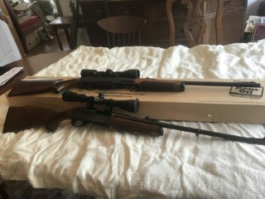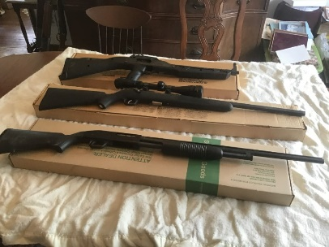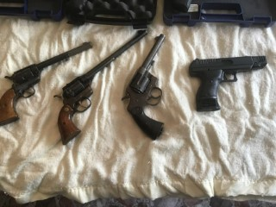

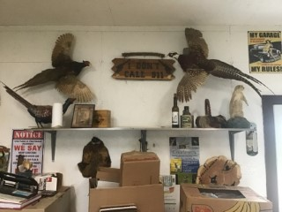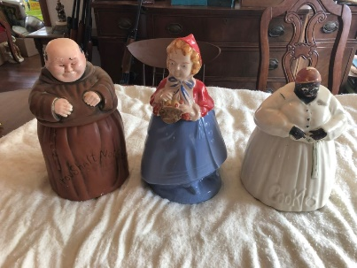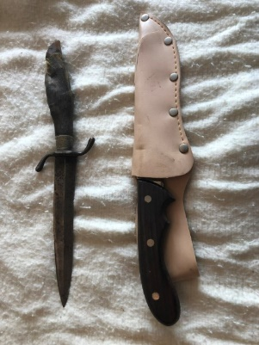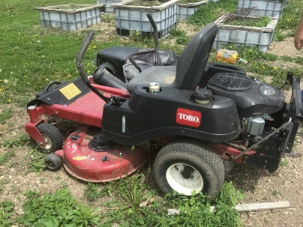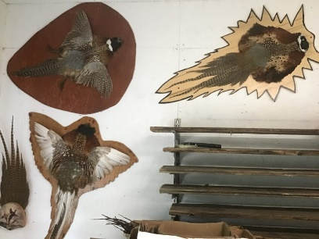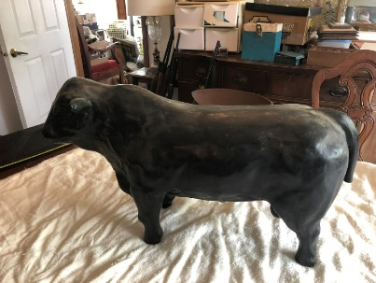

**Ronnie Ehlers Estate – Owner**

**For information contact Russell Ehlers (605) 730-3214**

Sale Conducted by: **Haines Auction Company**

Photos & Complete listing can be found at **www.hainesauctions.com** or by contacting

Wayne W. Haines - Phone: 605-680-0612 - Email: hai9@midstatesd.net

Eric Nowotny (605- 680-0804) — Tylor Stetson (605- 630-0747) — Paul Munsen (605- 680-1450)

**Collectibles**

Miscellaneous coins & tokens from White Lake, cast iron coin banks, model car & tractors, 150 piece cookie jar collection, including every holiday and season, animals, & figurines. Campbell Soup collection- mugs, signs, displays and miniatures. Dozens of figurines, cups & saucers, cream and sugar sets, vases, salt & pepper sets, many items still undiscovered.

**Sporting Equipment**

**Knives NIB**: Founding Fathers Native American 4 piece folding knife set, Bald Eagle Maxam, Buffalo Bill Wild West Bowie Knife

Several gun display cases, dozens of fishing rods and reels along with fishing tackle and tackle boxes, Several game bird mounts, including colored pheasants, mounted pheasant pelts, sharp-tailed grouse standing mount, wild turkey beard and feather mount, prairie dog mount, pheasant pictures and prints, metal signs, beer signs and displays, bird identification poster.

**Tools**

Carpenter tools, cabinet maker tools, woodworking tools and supplies, lathes, skill saws, miter saws, scroll saws, band saws, radial arm saw, chain saws, table saws, drill press, c-clamps, glue clamps, work benches, hand tools, wrenches, hammers, jacks, chains, nails, screws, hinges, tool boxes, cords, chains, air compressor, electric motors, tool boxes & totes, a very large 100 plus year old safe, Toro 421 zero turn lawnmower 22 HP -Kohler engine with bagger.

**Household**

Complete line of kitchen utensils, pots, pans, silverware, electric appliances and dishes. Full line of furniture, including claw feet, chair, couches, dining room table & chairs, bedroom sets, buffet, chests, shelves, china cabinet, and much more.

**Guns- 50 pistols and long guns to sell at 1PM**

**Pistols**

Longhorn 22 cal revolver, FLE Miami Fl model 15 22 LR, Hi Point model C-9 9mm, Colt Revolver, Smith & Wesson 40 cal, Smith & Wesson 22 A-1 22 LR, Charter Arms Target Bulldog 357 mag

**Henry Rifles new and in the box**

22 cal lever w/scope, 17 cal HMR lever w/scope, 223 cal lever action w/scope, 243 cal lever action w/scope, 308 cal lever action w/scope

**Other Rifles**

Remington model 760 270 cal w/scope, Remington model 760 30-06 w/scope, Remington model 7600 243 cal w/scope, Remington model 7600 308 cal w/scope, Remington model 572 22 cal pump, Remington model 6 22 cal long rifle, Marlin model 1894 357 cal lever action, Marlin model 336 30-30 lever action, Hi Point model 995 9mm lever action, Stevens model 66 22 cal bolt action, Ruger model 10 22 cal w/scope, Sears model 5 22 cal, Savage model 93 17 cal HMR w/scope, Garo shadow sport .177 w/scope NIB

**Remington Shotguns**

Magnum 870 12 gauge, Express 870 12 ga, Wingmaster 870 16 gauge, Express 870 20 ga, Wingmaster 870 20 ga, Wingmaster 870 12 ga short barrel with mag extension, Model 12-A square back 12 gauge auto

**Other Shot Guns**

Browning 16 ga squareback auto, Stevens model 512 12 ga over and under Stoger Uplander 12 ga side by side with extra 20 ga barrel, Baikal Russia 20 ga over and under, Savage model 555 410 ga over and under NIB, Savage model 330 12 ga over and under, Topper model 88 20 ga single shot, Mossberg 410 pump, Sportsman model 12 12 ga pump

**There are literally 100’s of items not listed. Ehlers Estate Auction will mark the end of an era.**