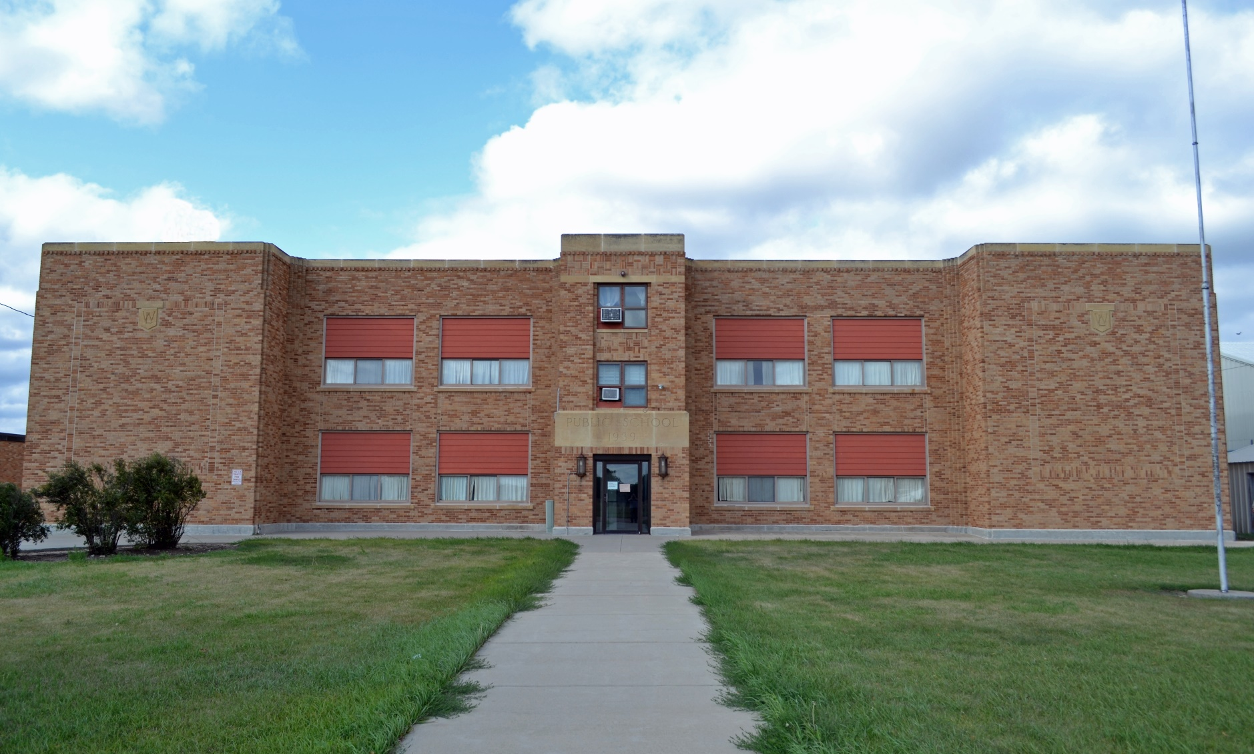

**Sunday October 14th, 2018 – 12pm   
Buildings to sell at 3pm  
Auctioneer’s Note:** The White Lake School District has constructed a new facility & will surplus the following items.

**AUCTION**

**Total Liquidation of Original White Lake School**

­­

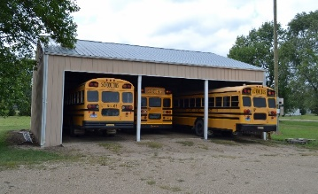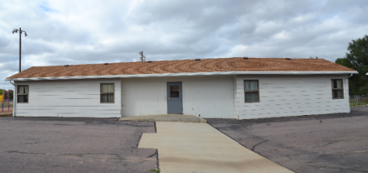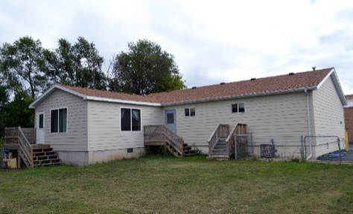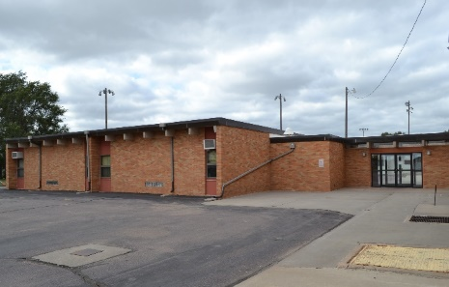

Chairs of all sizes, office desks, student desks, digital projectors, screens, projectors, smart boards, black boards, white boards, dozens of metal filing cabinets, server rack, patch panels, shelving, clocks, books, stools, tables, decorations for various holidays, crafts supplies, paints & painting supplies, lesson books, printers, board games, dozens of upright lockers, trash cans, cleaning supplies, computer monitors, personal safe, 8mm film, old books, fire extinguisher, TVs (tube & flat panel), TV stands, VCRs, stereos, amps, speakers

**Shop Supplies** - 500-gal propane tank, shop supplies, shop tables, hand tools, T-squares, saws, drill press, table saw, clamps, vice, 2 air compressors, tool boxes, extension cords, shop vac, totes, brooms, bench sanders, band saw, dehumidifiers, new & used lumber

**Collectables** - Dozens of annuals from a wide range of years, photographs, maps, 3 panel roman plaster relief (donated by class 1913), American & South Dakota flags, large upright wooden cabinet, wooden desks, pictures of presidents, historic figures and events

**Science Equipment** - Diagrams, lab tables, lab equipment, scales, beakers, Bunsen burners, microscopes, petri dishes, books, balance scales, scale weights, model solar system

**Miscellaneous Items** - 2 pianos (1 upright & 1 counsel), keyboards, various musical instruments, music books, stage lights, coat racks & hangers, 10+ window mount AC units

**Hundreds of other Items too numerous to mention…**

**2 rings will be run during part of the day**

**Office & Classroom Equipment**

**To be moved -** Bus shed 36’x42’ colored steel square poles 3 - 12’ openings 13’ eves- fully wired with 125amp electrical service lights & outlets: possession May 2019

**To be moved** - West building (Music Building) fully modern single-story wood structure 20‘x80’ with 30’x48’ addition 2 bathrooms, utility room, central heat and AC.

**To be moved** - East building (Daycare) 40’x36’ main structure with 20’x18’ addition. This unit was a South Dakota licensed daycare. Full basement, handicap accessible, new heat pump, water heater, electrical, & plumbing.

**Long term lease** - 72’ x 80’ elementary building: 1965 brick structure consisting of 4 classrooms- 2 bathrooms, plumbing in each room built in AC. Property title available with survey at buyers’ expense

**For salvage** main 1939 3 story brick structure consisting of all remaining fixtures, furnishings, woodwork, metal, and electrical equipment

**More detailed information & additional photos can be found online at www.hainesauctions.com**

­­



**White Lake School District 1-3**

**Contact person (555) 249-2555**

Sale Conducted by: **Haines Auction Company**

Complete listing can be found at **www.hainesauctions.com** or by contacting

Wayne W. Haines - Phone: 605-680-0612 - Email: hai9@midstatesd.net

­­



**White Lake School District 1-3**

**Contact person (605) 249-2251**

Sale Conducted by: **Haines Auction Company**

Complete listing can be found at **www.hainesauctions.com** or by contacting

Wayne W. Haines - Phone: 605-680-0612 - Email: hai9@midstatesd.net

Mike J. Kiefer 605-999-3773 – Eric W. Nowotny 605-680-0804

**Announcements day of sale take precedence over all advertising**